AUBO Virtual Machine Usage Instructions

directory

1. Download  AUBO  Virtual Machine  3

2. Install  VMWare Workstation . 3

3. Open Virtual Machine  4

4. Upgrade the  AUBO  virtual machine programming environment version. 7

5 . Bring up the  Ubuntu  menu  bar and the Quick Launch bar. 9

6. Copy the project to a virtual machine. 10

7. Export the project from the virtual  machine12

# 1. Download **the AUBO** virtual machine

Network disk link: https://pan.baidu.com/s/19bVAScj7D0SYzzG5CymPjQ Extract code: sg9u After downloading, extract.

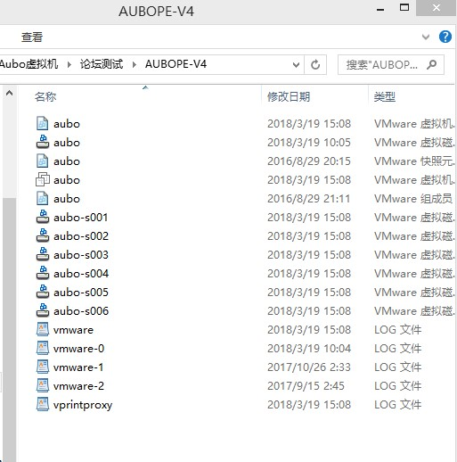

# 2. Install **VMWare Workstation**.

Find the software package and installation method on the Internet.

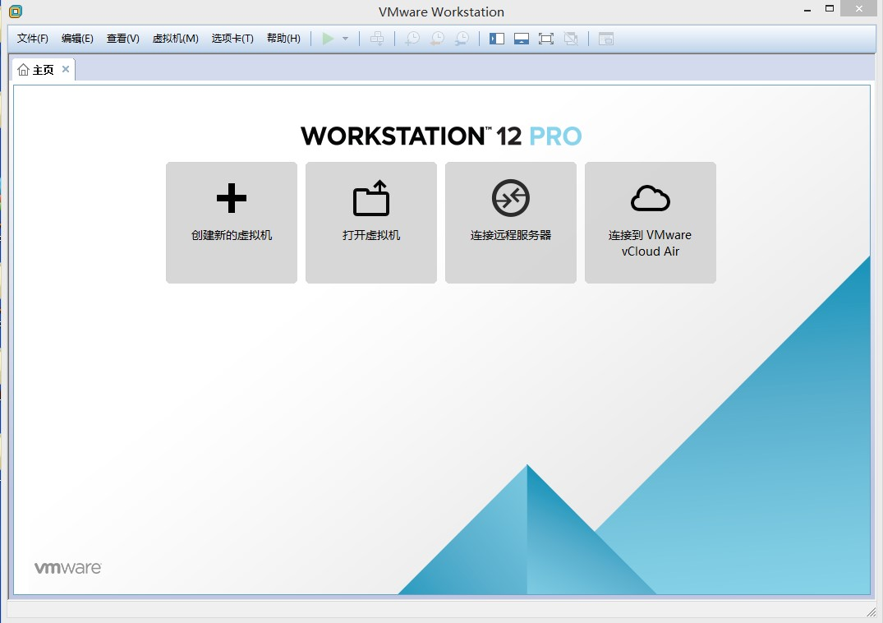

# 3. Turn on the virtual machine

After opening

，

Go to the following interface

。

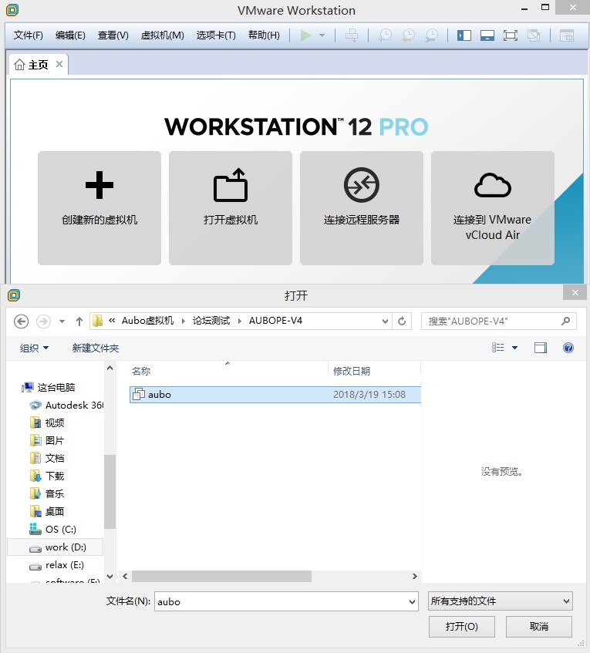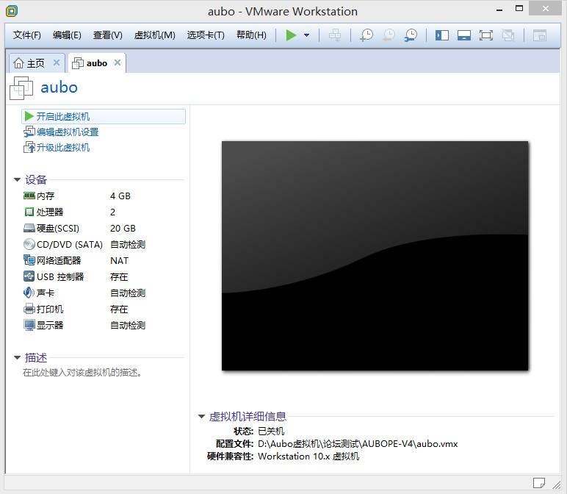

**1**

**2**

**3**

You can set the virtual machine according to the actual situation of the PC, such as my PC is 8G memory, set the virtual machine memory to 2G.

Once set up, it's done

，

Power on this virtual machine

。

click

I have replicated the virtual machine.

The system is loading

…

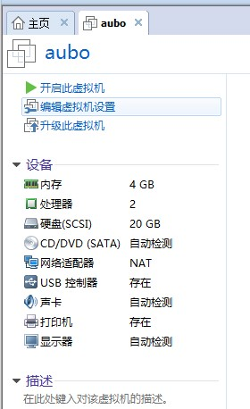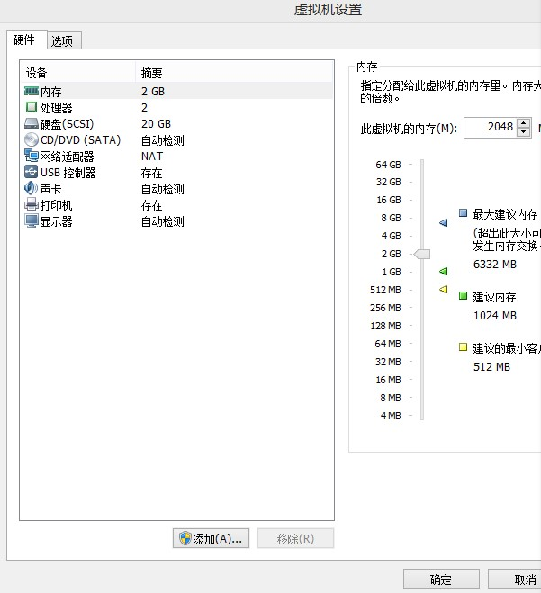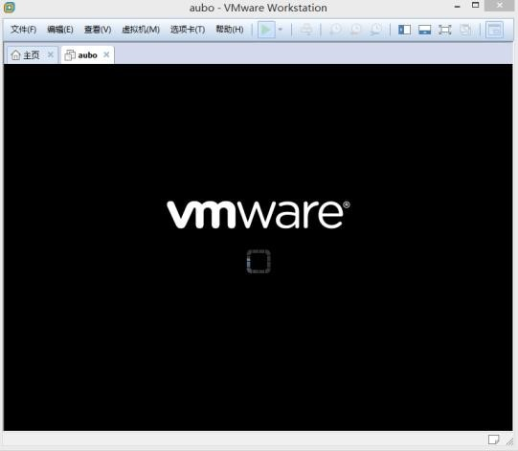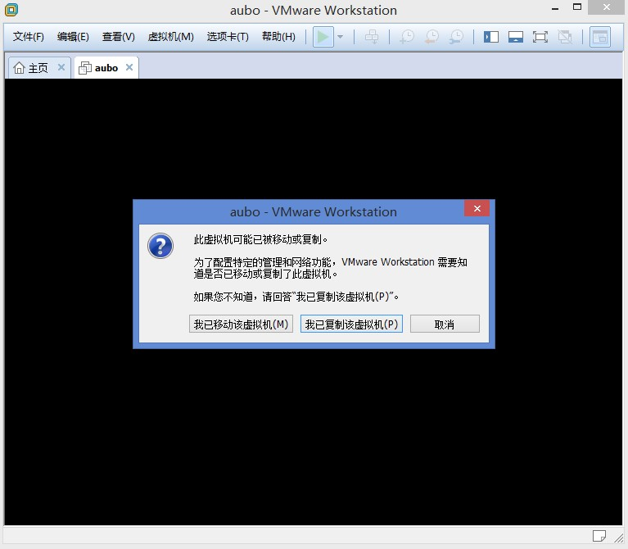

**1**

**2**

Enter the virtual machine.

Double-click to open

【

AUBORPE

] icon, open

AUBO

Programming environment.

click

【

Save

】

,

Click on the

Yes

】

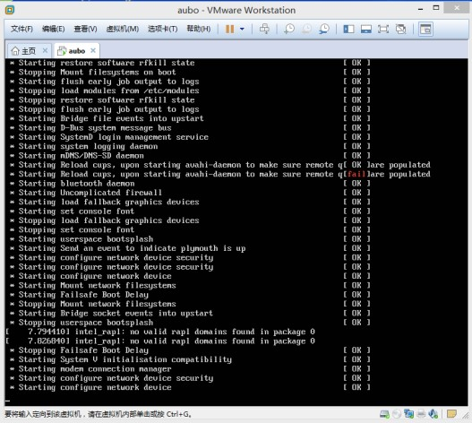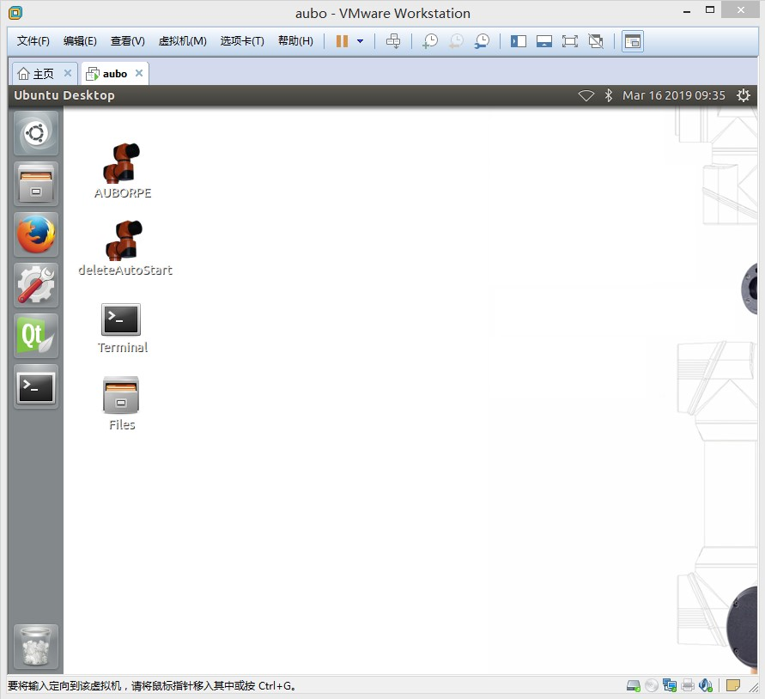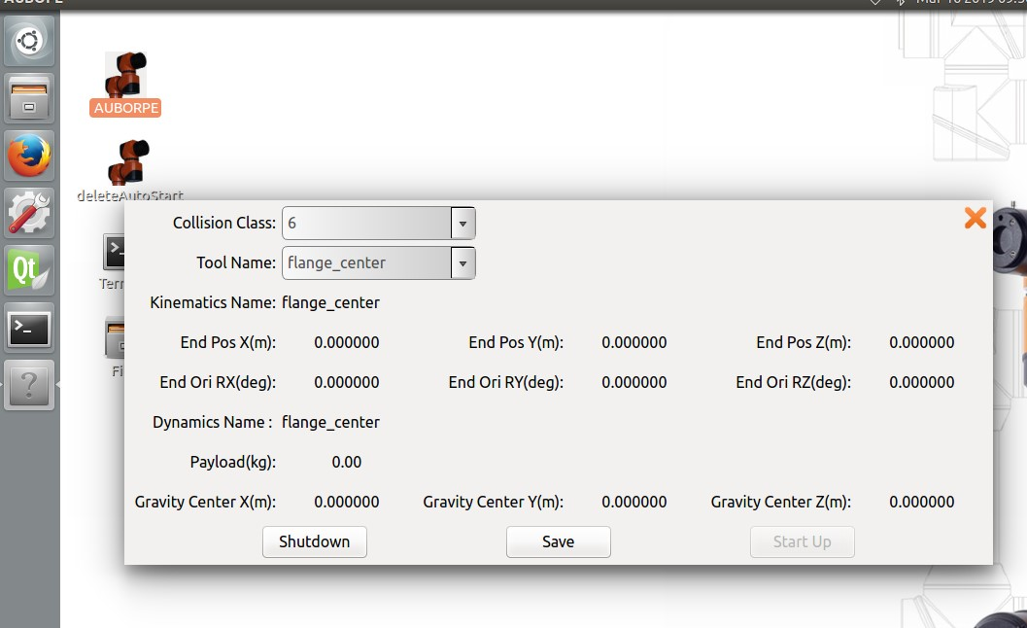

**1**

**2**

enter

AUBO

Virtual machine programming environment.

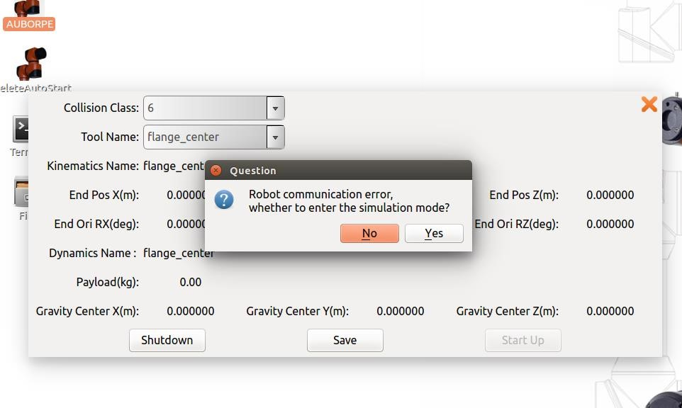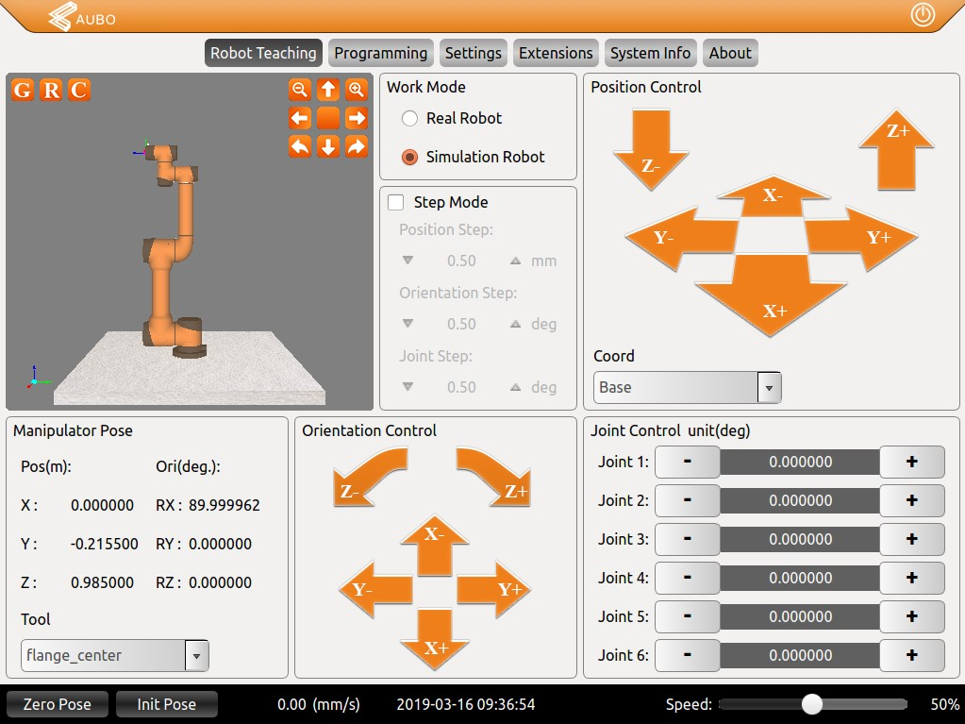

**3**

# 4. Upgrade the **AUBO** virtual machine programming environment version.

For example, from

In

4.0.19

Upgrade to

V4.3.5

。

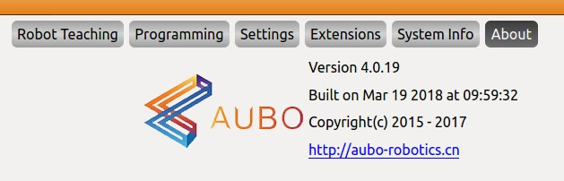

Copy the upgrade package to the "Home" folder, and the upgrade package can be downloaded from the official website of Aobo.

Rename, remove "

.aubo

”。

Right-click

，

Extract Here

，

Unzip here

。 Get

Aubo

ProgramUpdate

folder.

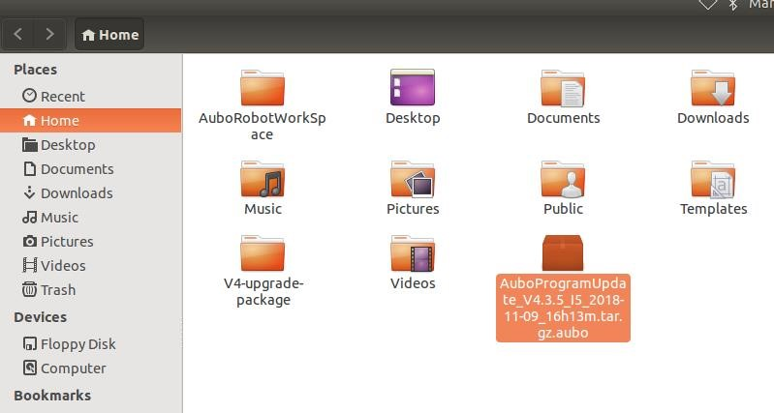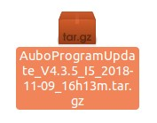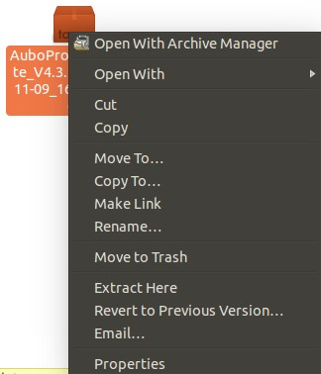

Enter the terminal, enter the command **cd AuboProgramUpdate**, enter the command**./upgrade.sh.x**, enter the upgrade...

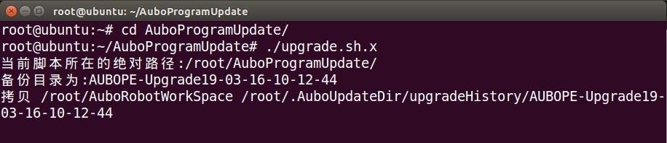 When the terminal can enter commands, the upgrade is complete.

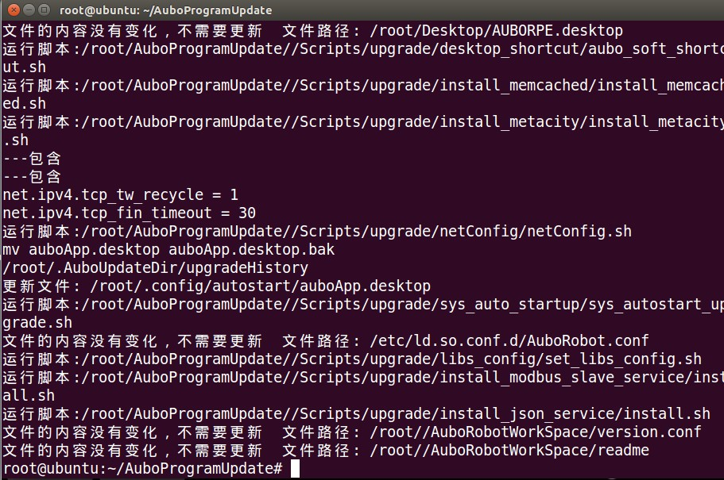 Enter the commands **reboot**, enter, reboot.

Check the software version and the upgrade is successful.

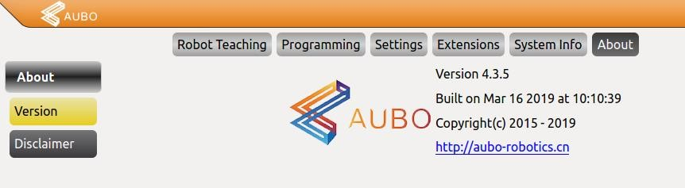

# 5. Bring up the **Ubuntu** menu bar and the Quick Launch bar.

After upgrading, the menu bar and Quick Launch bar disappear.

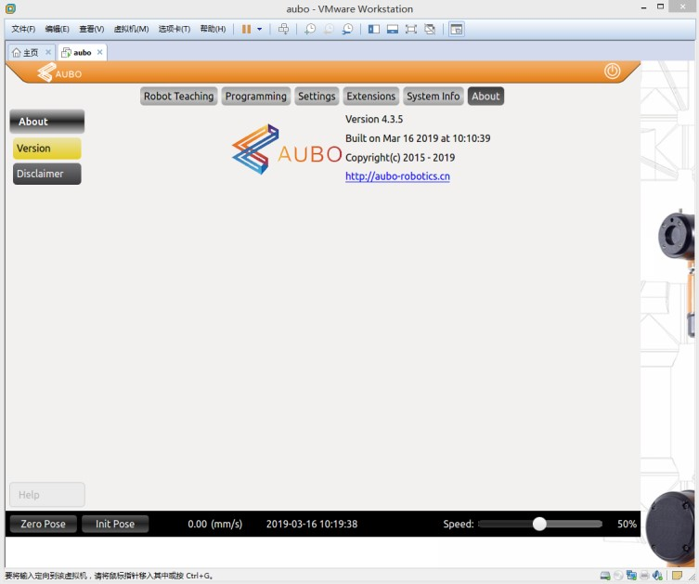

Ctrl + Alt + F1, go to the terminal. ubuntu login enter **root** password enter **user** enter

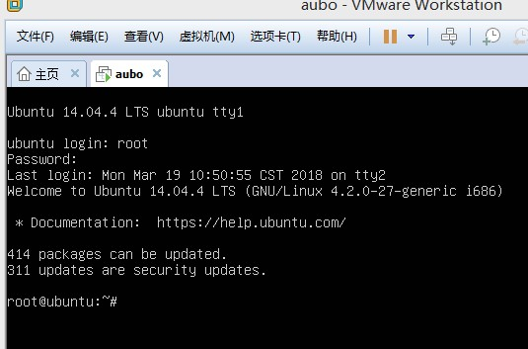

Enter the command

**mv .config/autostart/auboApp.desktop .config/autostart/auboApp.desktop.bak** 回车

Enter the commands **reboot**, enter, reboot

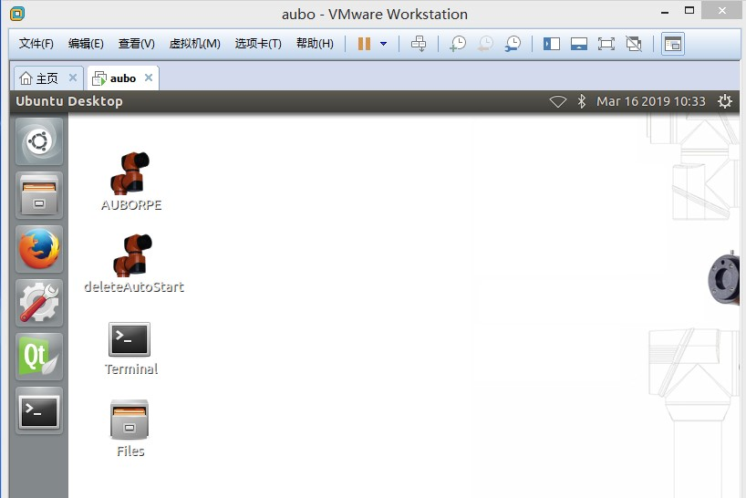

You can launch the programming environment by double-clicking the "AUBORPE" icon.

# 6. Copy the project to a virtual machine.

Prepare the project you will copy, such as one exported from another bot

 unpack

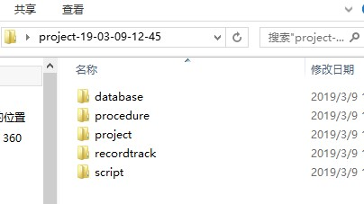

* database: variables, coordinate systems, security configurations and other parameters
* procedure: Procedure
* project: Engineering
* recordtrack: Track recording
* script: Script file

Copy all five folders to the following path in the virtual machine (you can also copy a folder or a file individually).

click

Merge

or

Replace

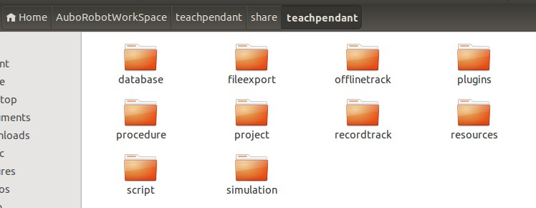

Open AUBORPE to see the imported projects.

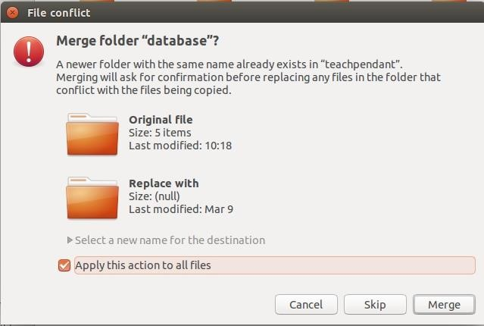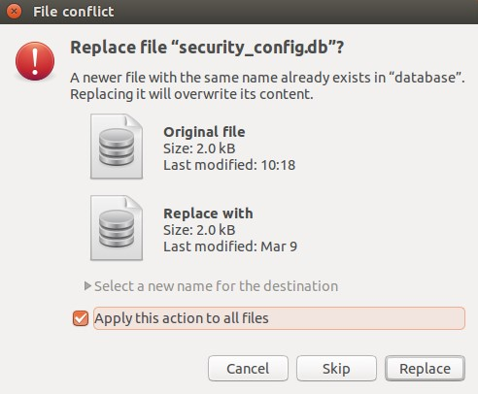

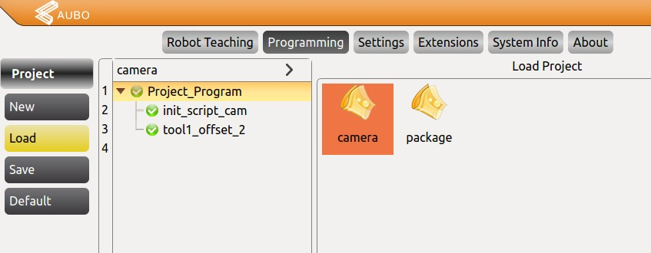

# 7. Export the project from the virtual machine

Go to the following path

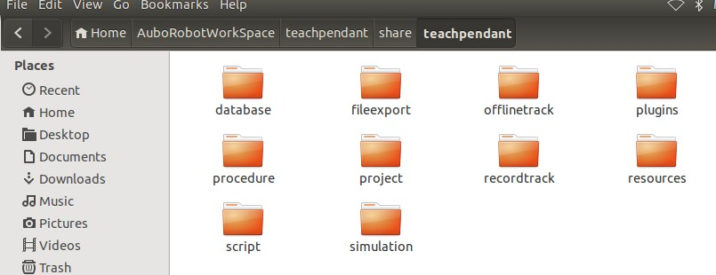

Copy the following 5 folders to a USB stick

* database: variables, coordinate systems, security configurations and other parameters
* procedure: Procedure
* project: Engineering
* recordtrack: Track recording
* script: Script file

Depending on the actual situation, you can copy only the folders or files you need.